

ECOMONDO 2024: Daily Update, 7th November 2024

Africa Green Growth Forum: The Mattei Plan for Sustainable Development

Two projects supported by the Mattei Plan for Africa were discussed on the third day of Ecomondo during the Africa Green Growth Forum: a Centre of Excellence for renewable energy training in Morocco and the development of the biofuels supply chain in Kenya. Organised by Ecomondo, the Ministry for the Environment and Energy Security, and the Mission Structure for implementing the Presidency of the Council of Ministers’ Mattei Plan, the event gathered key national and international stakeholders, including leading Italian energy companies Enel and Eni, which are already implementing on-the-ground projects in Africa, and the RES4Africa Foundation, which provides training to develop new professional skills in the energy sector.

Corrado Peraboni, CEO of Italian Exhibition Group (IEG), opened the Forum by highlighting the longstanding focus on Africa, a commitment that will continue in the future, fostering new opportunities for exchange and collaboration at Ecomondo.

The Moroccan project aims to establish a Centre of Excellence dedicated to renewable energy and energy efficiency training, designed to educate experts, administrators, and technicians from across Africa. This initiative, developed under the joint guidance of the Italian and Moroccan governments, seeks to build local expertise for sustainable energy development. In Kenya, the Mattei Plan is supporting an ambitious biofuels initiative that already engages over 100,000 small-scale farmers across 16 counties, with a target of reaching 200,000 in the coming years. The project focuses on producing vegetable oil from marginal land and non-food crops, creating rural income and market access for local farmers.

The event’s second session, moderated by Professor Fabio Fava, President of Ecomondo’s Scientific Technical Committee, explored new opportunities for cooperation in the circular economy. It highlighted practical case studies, presented by Confindustria Assafrica & Mediterraneo, with a focus on the textile, Waste Electrical and Electronic Equipment (WEEE), packaging, and bioenergy sectors.

Reuse, Repair, Rethink, Reform: Designing for Circularity and Responsible Innovation

This international conference explored the most advanced approaches in the circular economy, highlighting how European production of goods and services stands out globally by promoting values and quality that represent a distinctive industrial approach. Across two sessions, high-level participants addressed both the tangible aspects of circularity and the intangible facets of responsible innovation, with active involvement from the audience.

Angelo Salsi, former Head of Department at the European Commission and Chair of the morning session, noted in his opening remarks that we are witnessing a historic moment, as EU and global landscapes shift drastically in policy and economics toward greater awareness and support from all stakeholders and the broader community. Emanuele Bompan, Editor-in-Chief of Renewable Matter and author of What is the Circular Economy, provided an extensive overview of global developments, noting leading regions such as Europe, China, and South Asia, which are heavily investing in circular practices and advancing research. Emerging markets, including Malaysia, Thailand, Indonesia, and Brazil, are also gaining momentum. However, Bompan highlighted the need to elevate education and public discussion to accelerate this transition, which is essential for addressing risks not only to the environment but also to economic stability and national security.

Aurel Ciobanu, Director for Circular Economy at DG Environment, European Commission, joined directly from Brussels and outlined key EU measures promoting reparability, reuse, and extended product lifespans. Initiatives include the recently adopted Right to Repair Directive, the Ecodesign for Sustainable Products Regulation (ESPR) with a focus on repairability, the Packaging and Packaging Waste Regulation (PPWR), and mandatory Deposit and Return Schemes (DRS) to be implemented by 2029. “The wind is blowing in support of these initiatives from both politicians and leading brands and manufacturers,” said Ciobanu. “There is strong certainty around specific measures within the circular economy agenda, which should be seen by investors and economic operators as a signal for their investments and as a call to rethink their business models continuously.”

The second session focused on the intangible aspects of sustainability, with contributions from academic experts and industry professionals exploring the role of ethics and culture in circular design. The event also featured an exhibition area where leading companies showcased their activities in reuse, repair, refit, and eco-design.

States General for Soil Health: Europe Rising to the Challenge of Regeneration

The third edition of the States General for Soil Health, organised in collaboration with the European Mission "A Soil Deal for Europe"б Re Soil Foundation, Coldiretti (Federation of Italian Farmers), and the National Bioeconomy Coordination Board, addressed critical challenges for soil protection in Europe. According to the European Soil Observatory, 60 to 70% of EU soils are currently undergoing degradation processes, with an annual loss of 7.5 million tonnes of CO₂ from agricultural land. Special attention was given to Mediterranean ecosystems, warming 20% faster than the global average.

The session covered updates on European regulations, with topics ranging from carbon farming to nature-based solutions, and placed particular emphasis on the progress of the European Mission "A Soil Deal for Europe". A series of innovative case studies were presented, including the FIBSUN and BeonNAT projects, which aim to enhance the value of biomass from marginal lands.

Massimiliano Conti, Italy's Ministry of Environment and Energy Security, highlighted in his remarks during the event: “Soil is a vital, limited, non-renewable, and irreplaceable resource. Its health is crucial for environmental quality, public health, and economic development. Degraded soil presents a complex and challenging issue, which is why it will be one of the key topics at COP29, set to open in Baku at the end of the month.” Conti further explained that, as of July 2023, the European Commission has begun negotiations for the Soil Monitoring Law. “As a ministry, we are actively involved in this process, aiming to ensure scientifically valid monitoring, plan sustainable management interventions, remediate contaminated sites, and establish long-term, sustainable soil management.”

Water Infrastructure: Status Update on Government Commissioners

The event provided an update on the activities of the Government's Extraordinary Commissioners responsible for water infrastructure, resources, and services, underscoring the increasing urgency of strengthening and completing water infrastructure to meet European directives and address emergencies driven by climate change.

Chaired by industry experts, including Francesco Fatone, Head of Ecomondo’s Scientific Technical Committee for the Water Sector, Polytechnic University of Marche, and Alessandro Bratti, Po River Basin Authority, the session featured contributions from the Extraordinary Commissioners. Special attention was given to activities in water purification, with a particular focus on interventions in Sicily, Calabria, and Campania, as well as efforts to mitigate the impacts of drought.

The presentation of projects for large, unfinished dams, such as those at Campolattaro in Campania and Pietrarossa in Sicily, which are strategically important for multi-year water storage, was of particular interest. The conference also covered funding provided by Italy’s Ministry of Infrastructure and Transport for strategic infrastructure, highlighting achievements, challenges, and future issues in the sector.

NB! All events organized by Ecomondo’s Scientific Technical Committee support the European initiative “No Women No Panel”.

PRESS CONTACT - ITALIAN EXHIBITION GROUP
head of media & corporate communication: Elisabetta Vitali; press office manager: Marco Forcellini, Pier Francesco Bellini; international press office coordinator: Silvia Giorgi; press office coordinator: Luca Paganin; press office specialists: Nicoletta Evangelisti, Mirko Malgieri; media@iegexpo.it

MEDIA AGENCY
Hill & Knowlton
Francesca De Angelis, +39 342 7460159 - francesca.deangelis@hillandknowlton.com
Valentina Corsi - +39 3270425730 - valentina.corsi@hillandknowlton.com
Alessio Ricciuto - alessio.ricciuto@hillandknowlton.com
Stampa Estera - Oksana Smirnova - smirnova.consultant@hillandknowlton.com

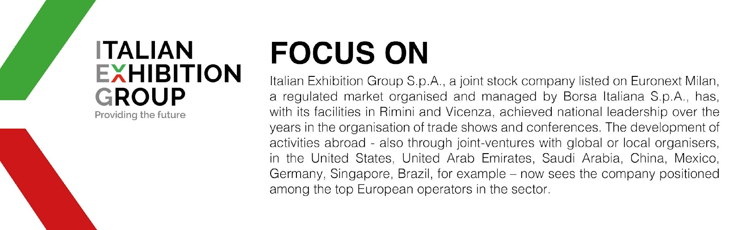

This press release contains forecast elements and estimates that reflect the management’s current opinions (“forward-looking statements”), particularly regarding future management performance, realization of investments, cash flow trends and the evolution of the financial structure. For their very nature, forward-looking statements have a component of risk and uncertainty, as they depend on the occurrence of future events. The effective results may differ (even significantly) from those announced, due to numerous factors, including, only by way of example: food service market and tourist flow trends in Italy, gold and jewellery market trends, green economy market trends; the evolution of raw material prices; general macroeconomic conditions; geopolitical factors and evolutions in the legislative framework. Moreover, the information contained in this release does not claim to be complete, and has not been verified by independent third parties. Forecasts, estimates and objectives contained herein are based on the information available to the Company as at the date of this release.

